Dice Demo Documentation

The primary purpose of the dice demo is to give an example of rigid body simulation using the Ghost SDK. The rigid body in this case is a cube that’s confined to a box environment. The cube has several physical properties that control how it responds to collisions with the PHANTOM’s surface contact point as well as the bounding environment.

You can interact with the cube in two fundamental modes. The first mode involves poking at it with your 3D cursor. Every time you make contact with the cube, you impart some force on a face of the cube. This can result in both linear and rotational motion. The second mode of operation allows you to grab hold of the cube and directly control its position and orientation. While in this mode, you can feel the bounding environment via the cube’s collision interactions. To activate this mode, simply hold the stylus button while making contact with the cube. The cube will then attach itself to the PHANTOM’s endpoint.

While you’re playing with this demo, you can also experiment with modifying some of the dynamic physical properties. As a first note of caution, changing the simulation parameters may lead to numerical or mechanical instabilities, so don’t be surprised if the cube’s behavior becomes erratic.

The dialog box displayed below depicts the physics parameters that can be modified by the user at runtime. The first set of parameters is grouped under the heading “Collision Feedback” and is used for controlling the cube’s response when colliding with and penetrating the bounding environment. These settings are used within a proportional, integral, and differential controls model for responding to environment collisions with the cube’s 8 corner vertices. The other properties grouped under the heading, “Environment Feedback” is used for the rigid body simulation in determining the kinematics behavior.

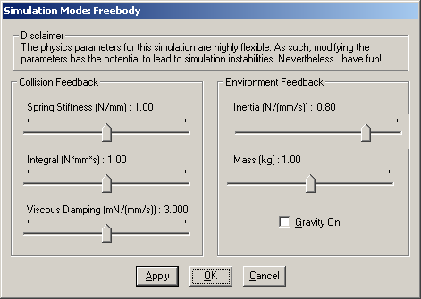

The aforementioned “Collision Feedback” parameters are set specifically for the two different modes: freebody and grab mode. When the cube is behaving as a freebody, the parameters tend to be set high, which offers the advantage of having stiff interactions with the bounding environment. However, when grab mode is enabled, the parameters need to be set lower to avoid mechanical instabilities with the PHANTOM that result from high stiffness interaction. You can interactively change these settings while the dialog box is active and then hit the “Apply” button to immediately experience the results.

Here’s a quick guide on how to interpret these parameters and to have some intuition for your own development efforts. In general, you want to specify control coefficients such that they lead to a critically damped system (i.e. errors tend towards zero over time).

The proportional control coefficient (sometimes referred to as stiffness) is typically the most important in a haptics application. The coefficient dictates the relative force to be applied in response to a surface penetration. In physics speak, this is basically hook’s law, which governs the behavior of springs. When using Ghost, you can typically get the maximum proportional gain for your PHANTOM by calling gstPHANToM::getMaxGain() on your PHANTOM instance. Using a proportional gain higher than this value will result in frequent buzzing or max force errors.

The second most important controls parameter is the differential control, which provides velocity damping. By definition, differential control is proportional to the change in position over time. It will generally try to dampen velocity in the system and is useful in promoting critically damped behavior.

The third less commonly used parameter is integral control. This works great for eliminating any residual error in the system but takes time to work effectively. This form of control is a summation of penetration depth over time, thus you will often feel the die gradually ramp up its force until the penetration depth goes to zero.

When applying these terms to different PHANTOMs, you’ll find that each PHANTOM responds a little differently. Settings that work well for a PHANTOM Model A 1.0 will not necessarily work well with a PHANTOM 6DOF 1.5. Since this demo can make use of 6 degrees of force feedback (i.e. forces and torques), you have to be even more conservative when dealing with a 6DOF device in a generalized force model. When a 6DOF is used with the program, the stiffness and damping are automatically set lower than normal. This results is a more mechanically stable model, but the tradeoff is rigidity in the cube’s grab mode interactions.

Note: There are some known limitations to the numerical and mechanical stability of this demo program. You may find that the extents of the workspace exhibit buzzing in the PHANTOM arm or that the cube doesn’t always reach a stable resting state when forced into corners. These are partially due to the appropriateness of the control parameters for the particular collision type. This demo could also benefit from using a rotational spring-damper model for controlling torques.

